**CHARLIE TEAM**

**James Brown III**

**Alexis Mitchell**

**Gabe Conner**

**Outland Adventures Case Study – Milestone #3**

**Report# 1 - Booking Trends by Destination**

Outland Adventures has been paying close attention to how bookings shift across its destinations in Africa, Asia, and Southern Europe. By organizing reservations by year and location, we will be able to get a clear view of changing travel preferences. A recent check done on the data has shown that there is a possible downward trend in popularity for one or more regions offered, and having this insight into how our customers feel about certain locations will provide us with the information needed to decide what trips to promote, or, in the worst case, drop from our offerings completely. See below printout for status.

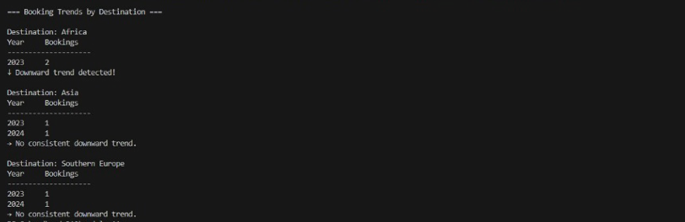

**Report# 2 - Equipment Over 5 Years Old**

Blythe and Jim are a little concerned about the age of some of the inventory. Are there inventory items that are over five years old? The purpose of this report is to identify equipment that may need to be upgraded or checked over if it's 5 years or older. Since none of the equipment in our database is over 5 years old, both reports came back with an empty list.



**Report# 3 - Equipment Inventory and Transactions**

Outland Adventures maintains a detailed inventory system for its hiking and camping equipment. Each item is tracked by a unique ID, name, type, purchase date, condition/status (available, rented, or sold), and quantity. Inventory is automatically updated when items are rented, sold, returned, or restocked. Rented items are retained for future use, while sold equipment is permanently removed from stock. See below for the current status.

